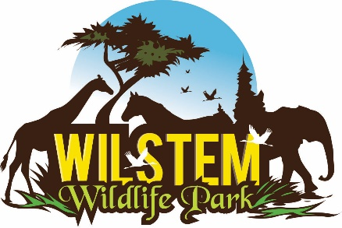
Welcome to Wilstem Wildlife Park!
We are committed to the safety of our guests, animals, and employees as we navigate through the COVID-19 pandemic with all of you. We are closely following the new guidelines and information being put out daily by the CDC and our government and have made the following procedures part of our daily routines as part of this effort.
Please note: FACE MASKS ARE STRONGLY ENCOURAGED but no longer required
- We are requiring all guests thoroughly wash and sanitize their hands before entering or leaving any of our encounter buildings or Basecamp.
- We have hand washing stations and hand sanitizer available in all of our locations.
- Our large encounter locations and open space will allow you to continue to practice social distancing protocols, and we encourage you to do so.
- Our staff is frequently sanitizing common area locations and counter spaces.
- Doors to our encounter buildings will remain open whenever possible to allow open air flow and minimize door contact.
- All employees will be required to stay home if they are experiencing any type of symptoms or are running a fever. They will be obligated to use proper hand-washing procedures and follow frequent sanitizing protocols throughout the building.

We are happy to have you here and hope you enjoy your visit!

